**Experiment No. 2**

**Aim:** To create Bucket using S3.

Step 1: Getting started with S3

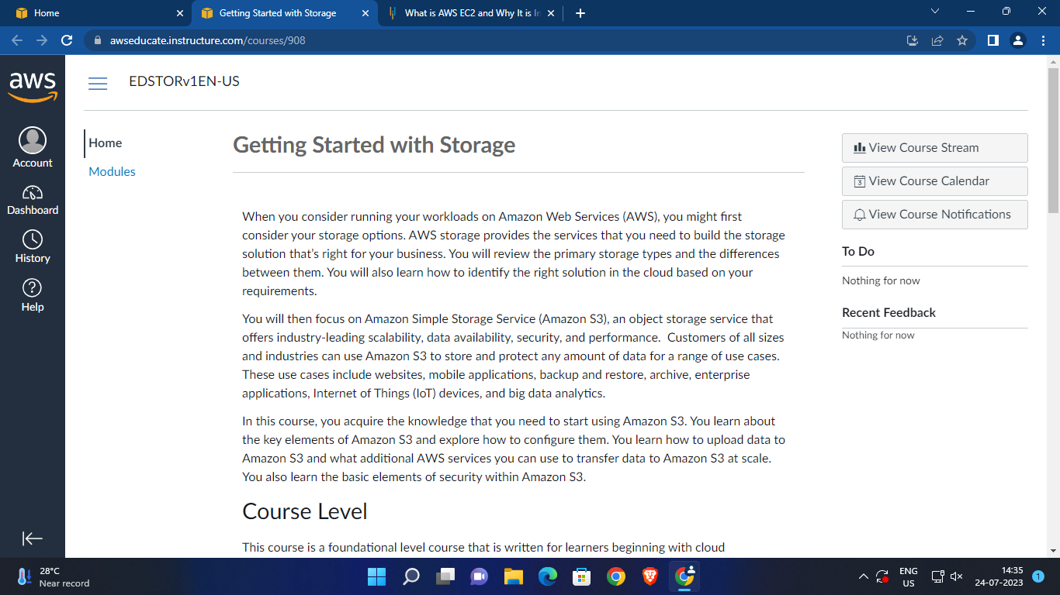

Step 2: Click on Next

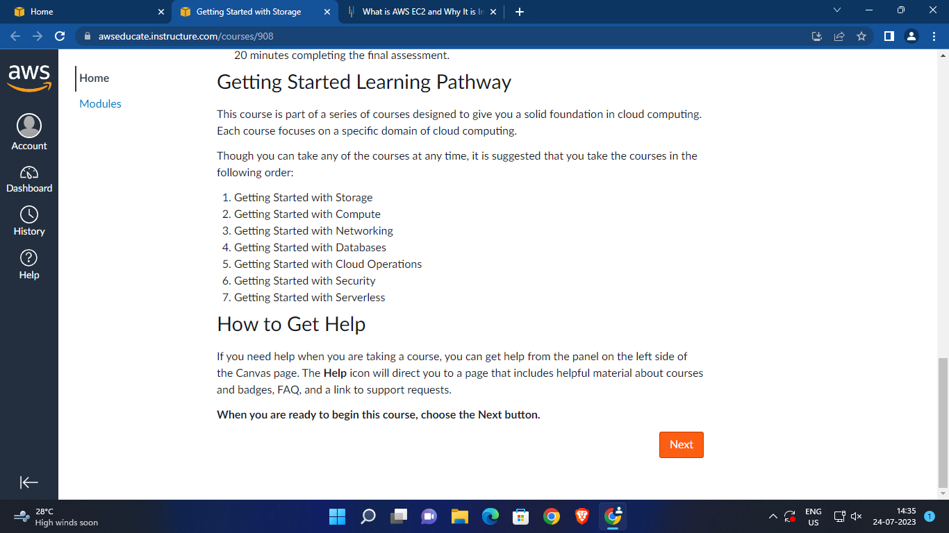

Step 3: Start S3 Lab

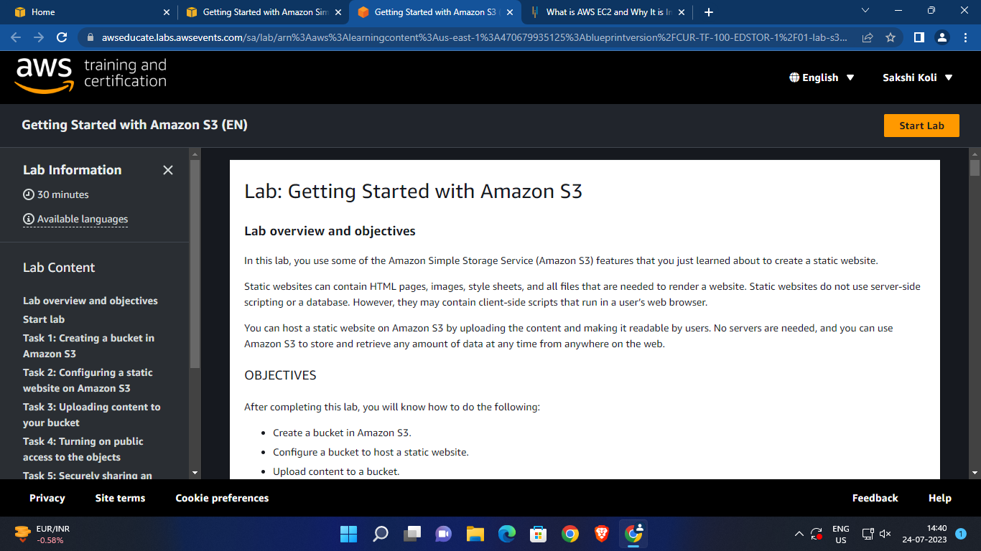

Step 4: S3 Lab is ready, Click on open console.

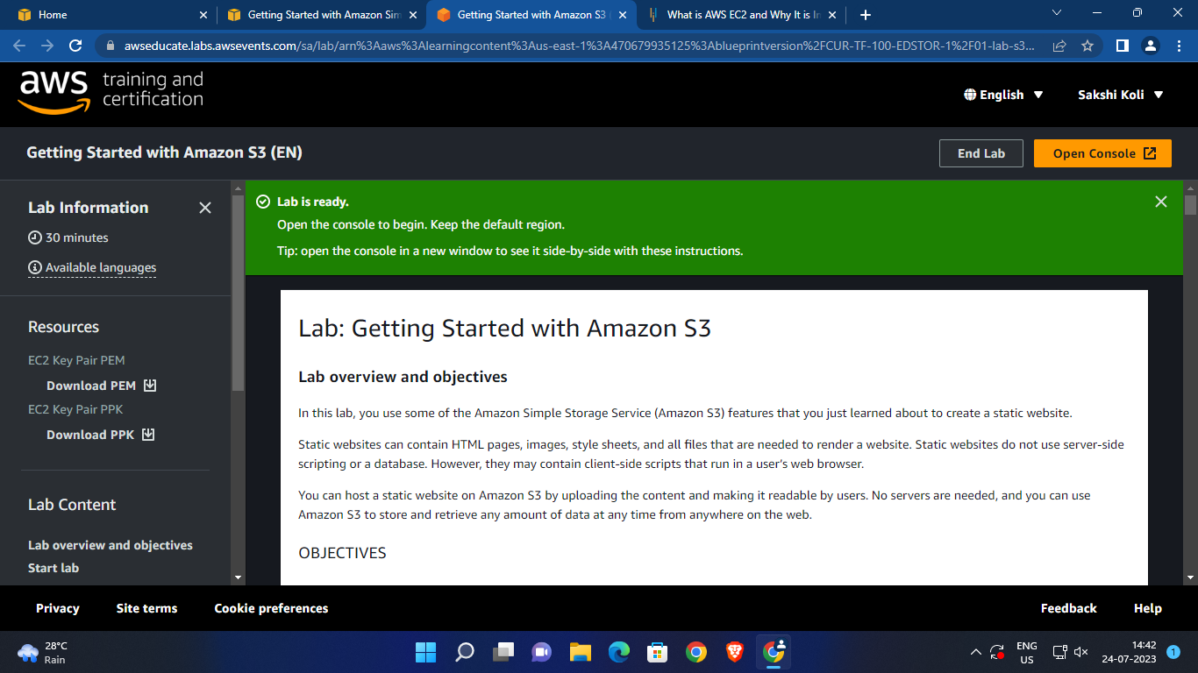

Step 5: Click on Services.

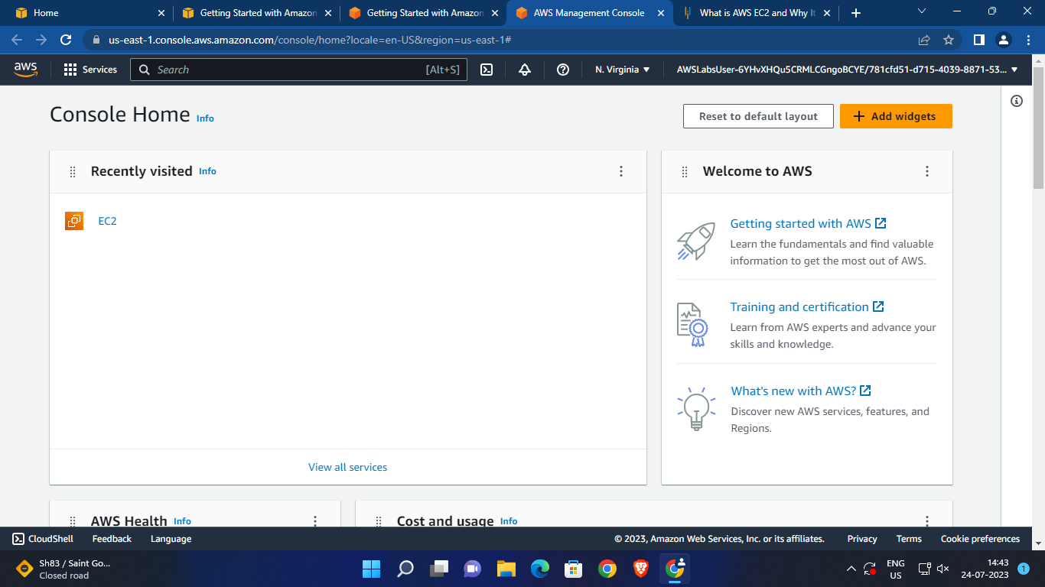

Step 6: Click on Storage.

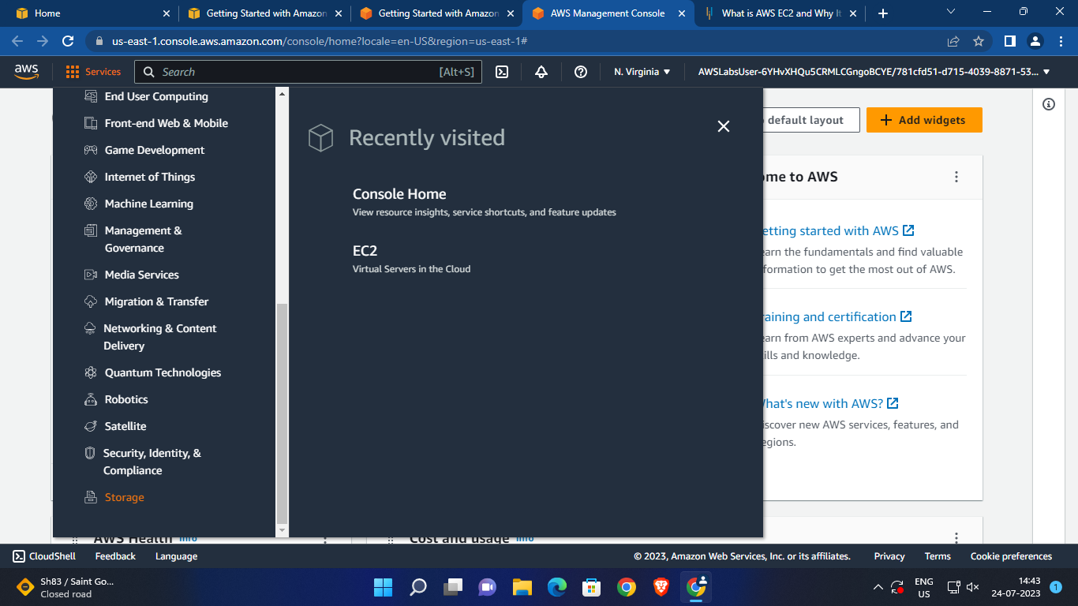

Step 7: Click on S3.

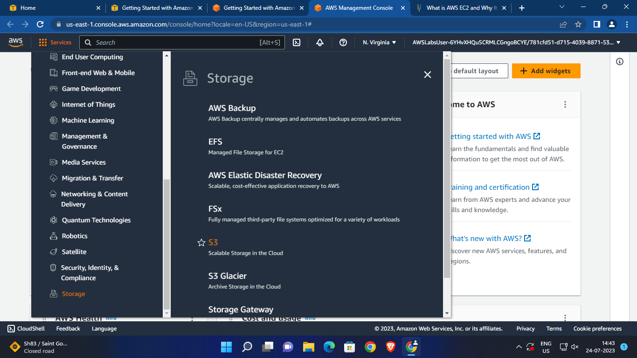

Step 8: Click on create Bucket.

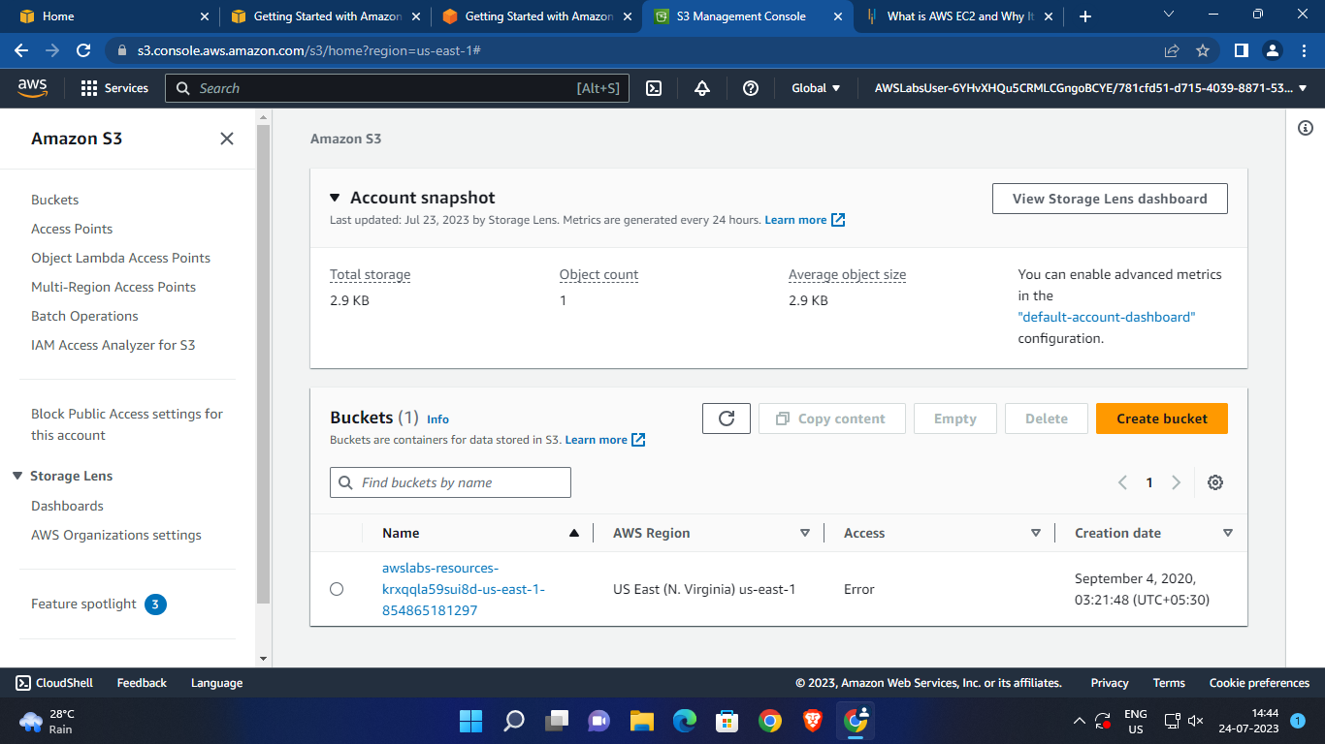

Step 9: Give name to your Bucket.

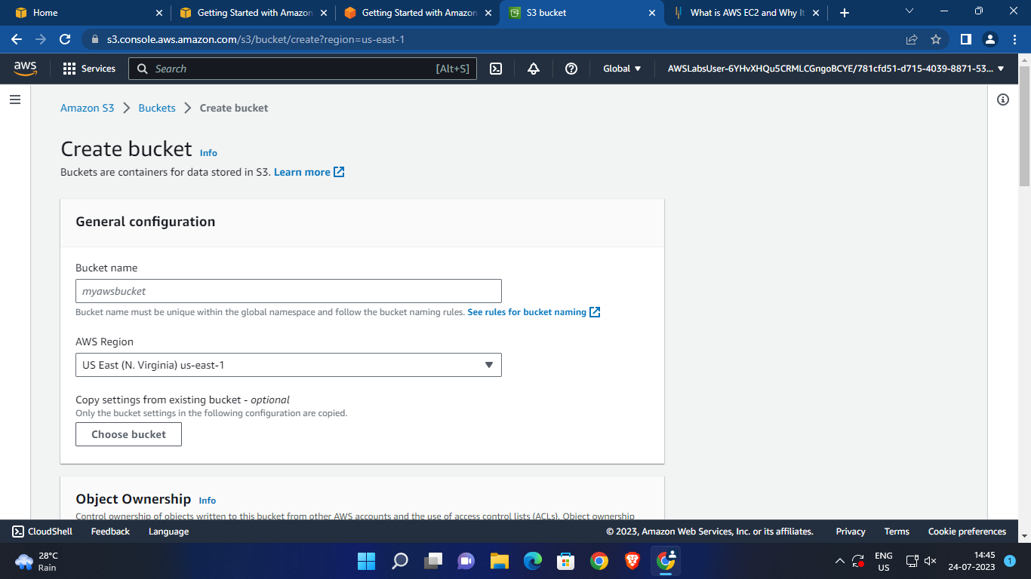

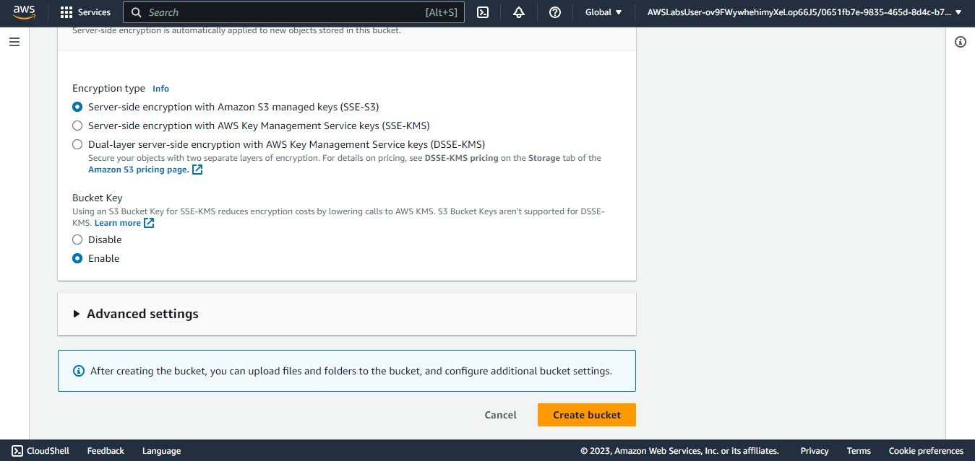Step 10: To create a new bucket, click on Create Bucket.

Step 11: Bucket is successfully created.

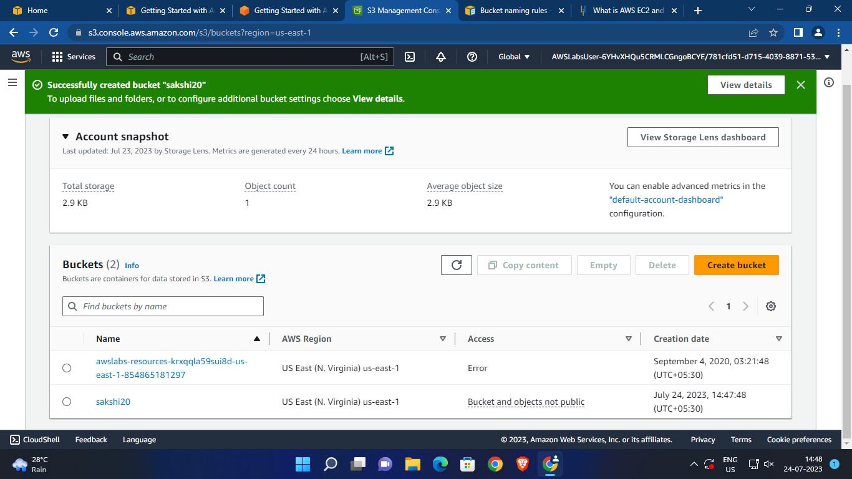

Step 12: Select the file you want to upload by clicking on upload.

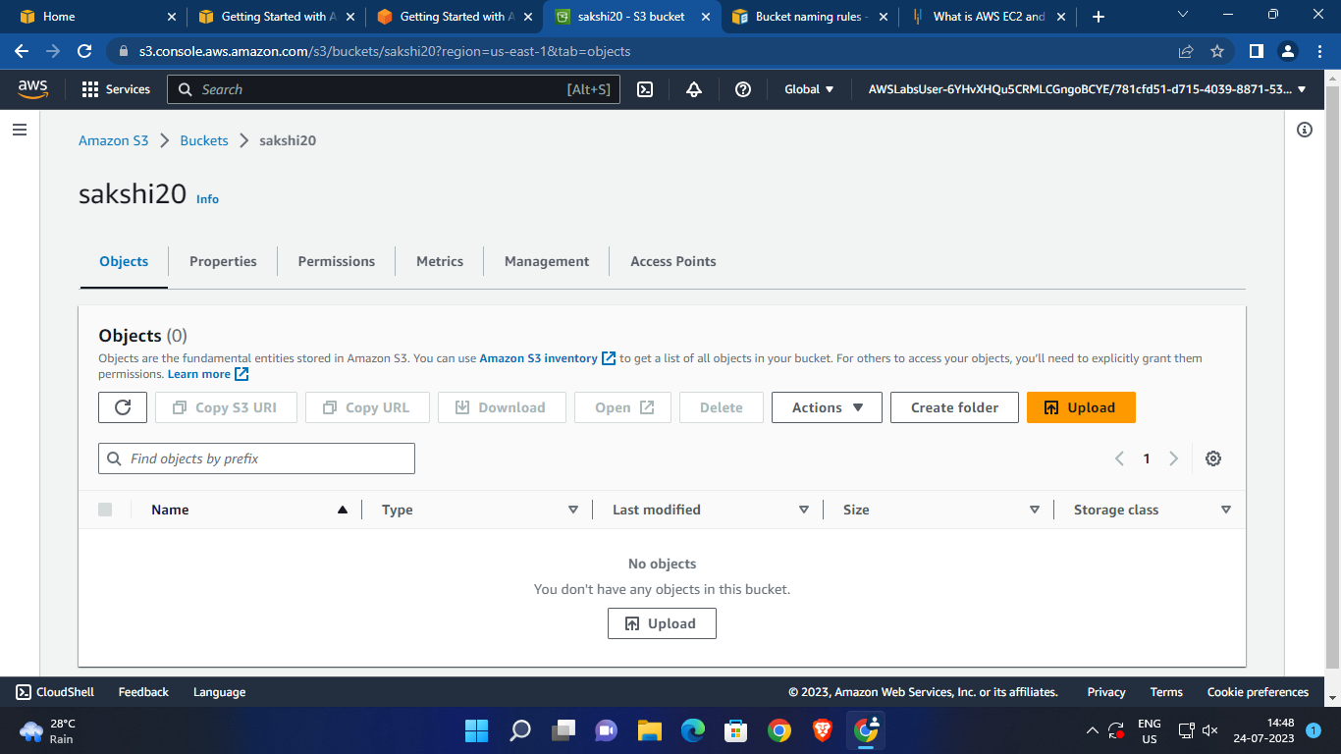

Step 13: Successfully uploaded the file.

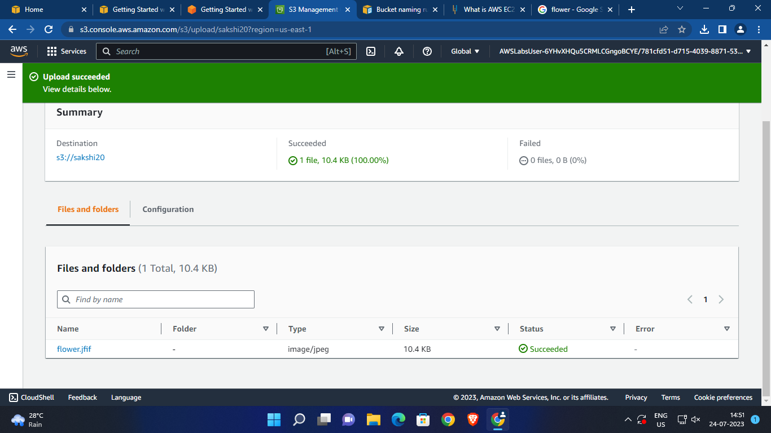

Step 14: View file by clicking on filename.

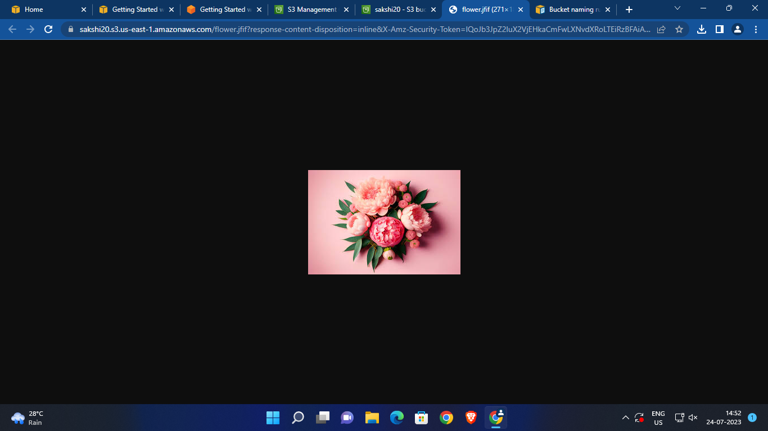

Step 15: Click on delete button to delete bucket.

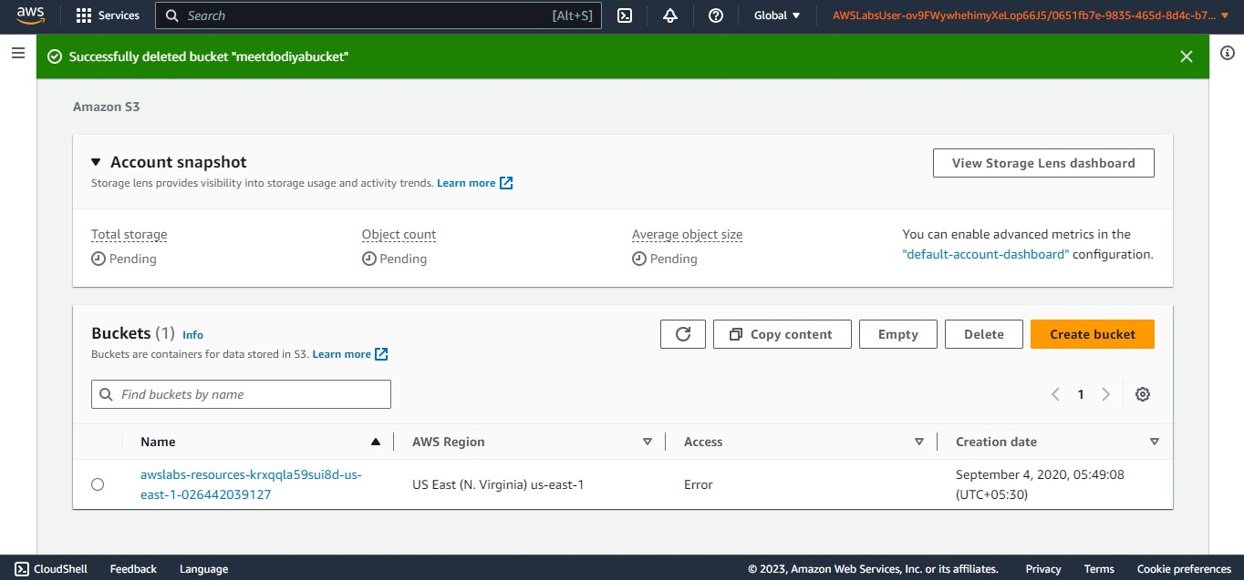

Step 16: Bucket is successfully deleted.